PROJECT

Deploying Azure protected Geo-Redundant Solution having path based routing

# Business Scenario

The Tyrell Corp wants to build a highly secured Globally distributed application. This application serves two types of content: images and dynamically rendered webpages. As their user base comes from across the globe this must be geographically redundant. The design demands that it should serve its users from the closest (lowest latency) location to them. For distinction Tyrell Crop has decided that any URLs that match the pattern /images/* are served from a dedicated pool of VMs that are different from the rest of the web farm.

Design the Load Balancing architecture for Tyrell Crop.

For this sample do it in East US region, then you can select any other region and add those Application gateway on created Traffic manager.

# Overview

The main tasks for this exercise are as follows:

1. Login to Azure Portal
2. Provision Application gateway
3. Add application gateways to the Traffic Manager endpoints

FOLLOWING STEPS TO ACHIEVE ABOVE GOAL

**STEP 1 : CREATING RESOURCE GROUP**

* Login **azure portal**
* In the navigation pane on the left side of the Azure Portal, click **All services**.
* In the **All services** blade that displays, click **Resource groups**.
* In the **Resource groups** blade that displays, view your list of resource groups.
* At the top of the **Resource groups** blade, click the **Add** button.
* In the **Resource group** blade, perform the following steps:
* In the **Resource group name** dialog box, provide the value **nrg1**.
* In the **Resource group location** list, select East US.
* In the **Resource group** blade, click **Create**.

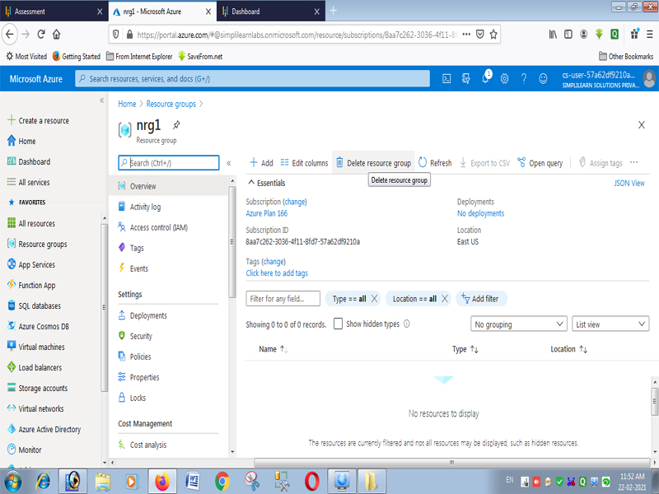

**STEP 2: Configure Traffic Manager PROFILE**

* In the Azure portal, click **Create a resource** > **Networking** > **Traffic Manager profile** > **Create**
* In the **Create Traffic Manager Profile** blade, perform the following steps:
  + - **Name**: tramanp
    - **Routing method**: Performance
    - **Resource group**: nrg1
    - **Resource group Location:** East US

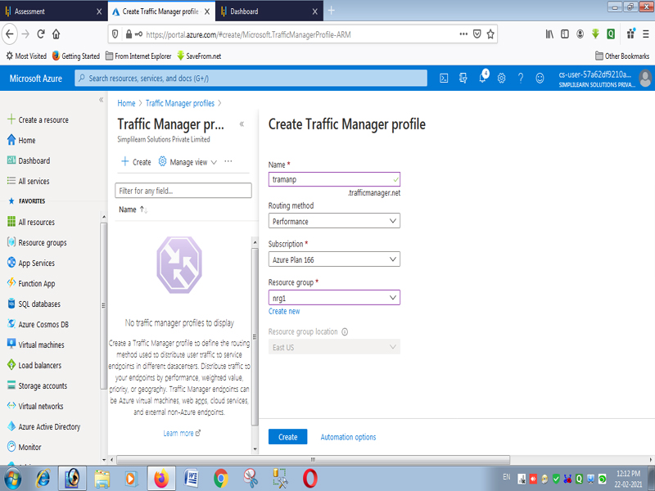

* Click **Create** to create the Traffic Manager profile.
* Change the Traffic Manager DNS TTL to 30 seconds (easier to validate a failover)

**STPE 3 : Create the application gateway**

* In the Azure portal, click **Create a resource** > **Networking** > **Application Gateway** > **Create**
* In the **Create Application Gateway** blade, perform the following steps on Basic tab:
  + - **Name**: agn1
    - **SKU size**: small
    - **Instance count: 2**
    - **Resource group**: nrg1
    - **Location:** East US
    - **Tier :** standard

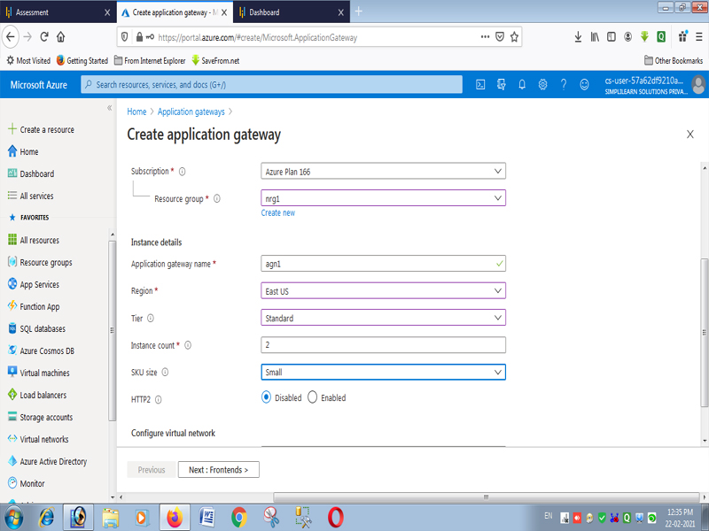

* On the **Settings** page, under **Subnet configuration**, select **Create virtual network**.
  + **Name**: vn2
  + **Address**: **10.0.0.0/16**
  + **Subnet Name:** Frontend (need a separate/exclusive subnet with any resource inside it)
  + **Subnet address range:** 10.0.1.0/24
* On the **Settings** page, provide below value and click okay
  + **IP Address Type**: Public
  + **Public IP address**: create new-> npb1

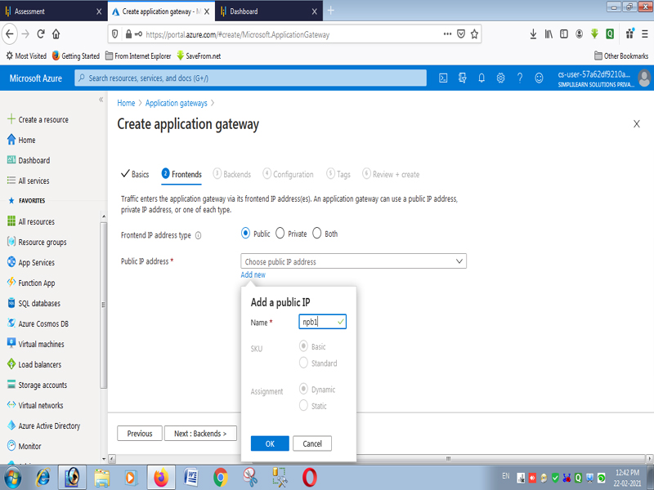

* on the **summery** page, validate the entries and click **ok**

Select **Next: Backends**.

**Backends tab**

* On the **Backends** tab, select **+Add a backend pool**.
* In the **Add a backend pool** window that opens, enter the following values to create an empty backend pool:
* **Name**: agbck
* **Add backend pool without targets**: yes
* In the **Add a backend pool** window, select **Add** to save the backend pool configuration and return to the **Backends** tab.

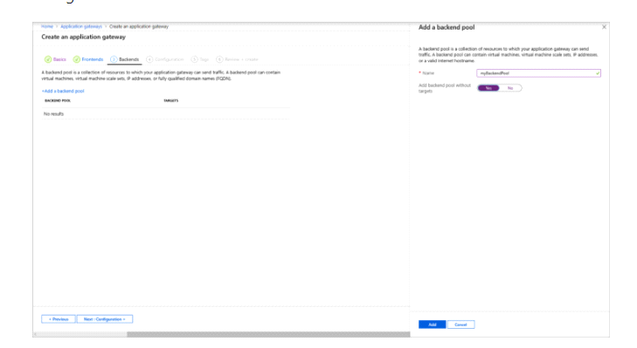

* On the **Backends** tab, select **Next: Configuration**.

**Configuration tab**

On the **Configuration** tab, you'll connect the frontend and backend pool you created using a routing rule.

* Select **Add a rule** in the **Routing rules** column.
* In the **Add a routing rule** window that opens, enter *rrb* for the **Rule name**.
* A routing rule requires a listener. On the **Listener** tab within the **Add a routing rule** window, enter the following values for the listener:
* **Listener name**: lin1.
* **Frontend IP**: public

Accept the default values for the other settings on the **Listener** tab, then select the **Backend targets** tab to configure the rest of the routing rule.

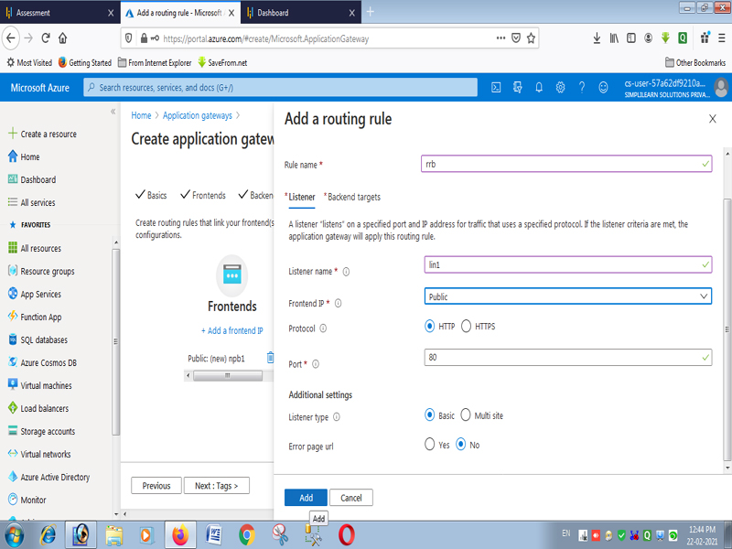

* On the **Backend targets** tab, select **myBackendPool** for the **Backend target**.
* For the **HTTP setting**, select **Create new** to create a new HTTP setting. The HTTP setting will determine the behavior of the routing rule. In the **Add an HTTP setting** window that opens,

**HTTP SETTING NAME** :  *htpag*

**Backend port** *: 80*

Accept the default values for the other settings in the **Add an HTTP setting** window, then select **Add** to return to the **Add a routing rule** window.

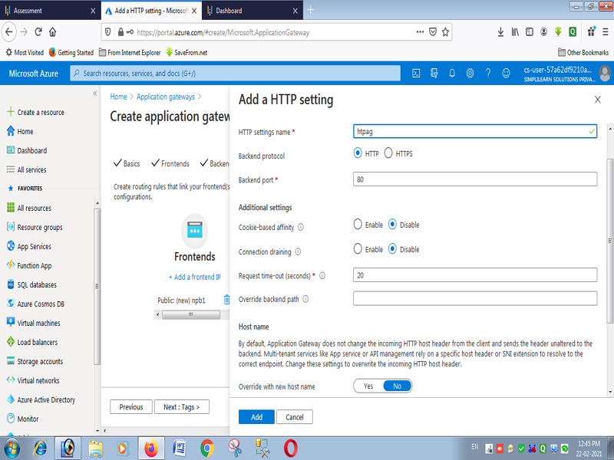

* On the **Add a routing rule** window, select **Add** to save the routing rule and return to the **Configuration** tab.
* Select **Next: Tags** and then **Next: Review + create**.

**STEP 4 : ADD SUBNETS TO VIRTUAL NETWORK VN2**

* From resource group- **nrg1** , go to the Vistual Network –**vn2**
* Click **Subnets**, and then click **Subnets**
  1. **Name:** sub2
  2. **Address** Space: 10.0.2.0/24
  3. **Name:** sub3
  4. **Address** Space: 10.0.3.0/24

**STEP 5: Create a virtual machine**

* On the Azure portal menu or from the **Home** page, select **Create a resource**. The **New** window appears.
* Select **Windows Server 2016 Datacenter** in the **Popular** list. The **Create a virtual machine** page appears.  
  Application Gateway can route traffic to any type of virtual machine used in its backend pool. In this example, you use a Windows Server 2016 Datacenter.
* Enter these values in the **Basics** tab for the following virtual machine settings:

For vm1:

* **Resource group**: nrg1.
* **Virtual machine name**: vm1.
* **Region :** East US.
* **Username**: *username*
* **Password**: goto@1234567.

For vm2:

* **Resource group**: nrg1.
* **Virtual machine name**: vm2.
* **Region :** East US.
* **Username**: *username*
* **Password**: goto@1234567.
* Accept the other defaults and then select **Next: Disks**.
* **OS DISK SIZE** : Standard
* Accept the **Disks** tab defaults and then select **Next: Networking**.
* On the **Networking** tab, verify that **vn2**  is selected for the **Virtual network** and the **Subnet** is set to **sub2 for vm1 and sub3 for vm2**. Accept the other defaults and then select **Next: Management**.  
  Application Gateway can communicate with instances outside of the virtual network that it is in, but you need to ensure there's IP connectivity.
* On the **Review + create** tab, review the settings, correct any validation errors, and then select **Create**.
* Wait for the virtual machine creation to complete before continuing.

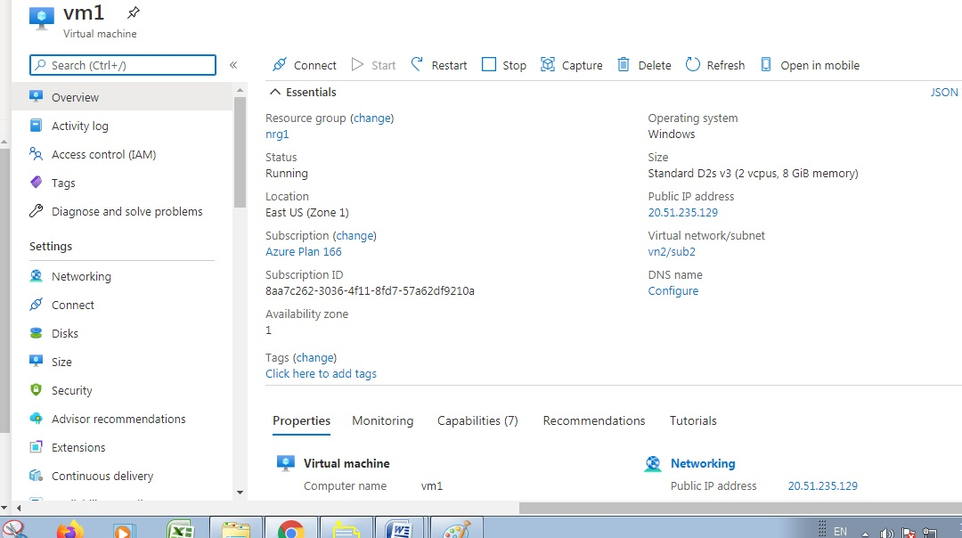

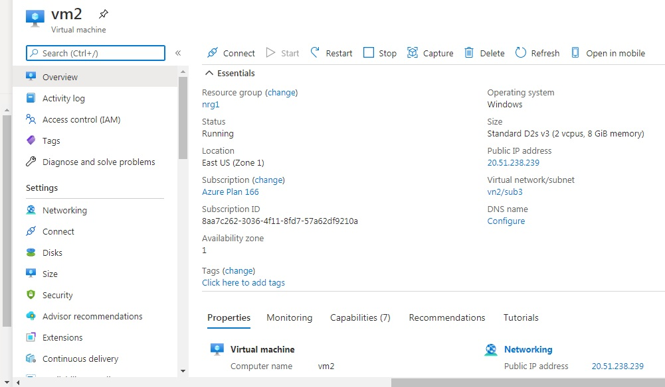

**Installing IIS in Both Vm1 and Vm2**

* From server manager click on add roles and features

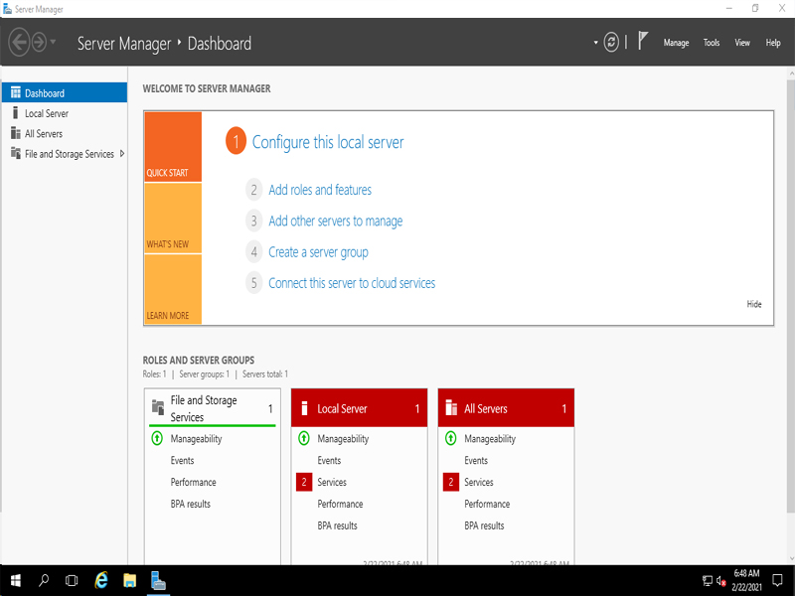

* From selection list select web server (IIS) from the list.
* Click next it will install web server .

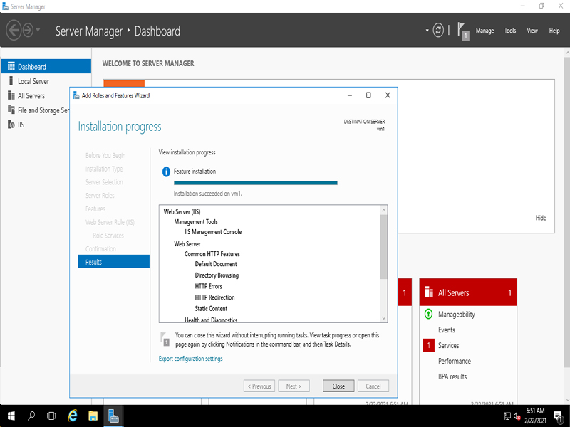

Same process is adopted from both vm to install IIS Web Server.

In the root of IIs make a folder named images and cope image.

In VM1 – first.bmp

In VM2 - second.bmp

**STEP 6 : Add backend servers to backend pool**

* On the Azure portal menu, select **All resources** or search for and select *All resources*. Then select  **agn1**
* Select **Backend pools** from the left menu.
* Select **agbck.**
* Under **Backend targets**, **Target type**, select **Virtual machine** from the drop-down list.
* Under **Target**, select the **vm1**  and **vm2** virtual machines and their associated network interfaces from the drop-down lists.

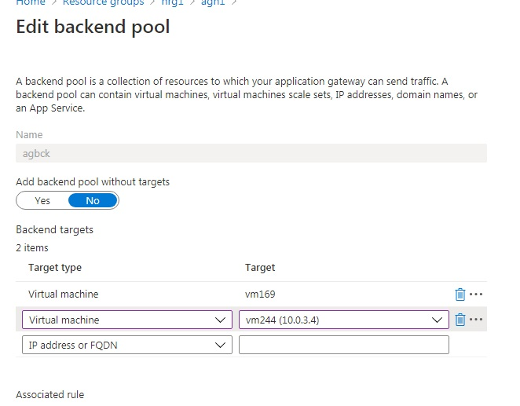

* Select **Save**.
* Wait for the deployment to complete before proceeding to the next step

**Test the application gateway**

Although IIS isn't required to create the application gateway, you installed it in this quickstart to verify if Azure successfully created the application gateway. Use IIS to test the application gateway:

* Find the public IP address for the application gateway on its **Overview** page.
* Copy the public IP address, and then paste it into the address bar of your browser to browse that IP address.
* Check the response. A valid response verifies that the application gateway was successfully created and can successfully connect with the backend.

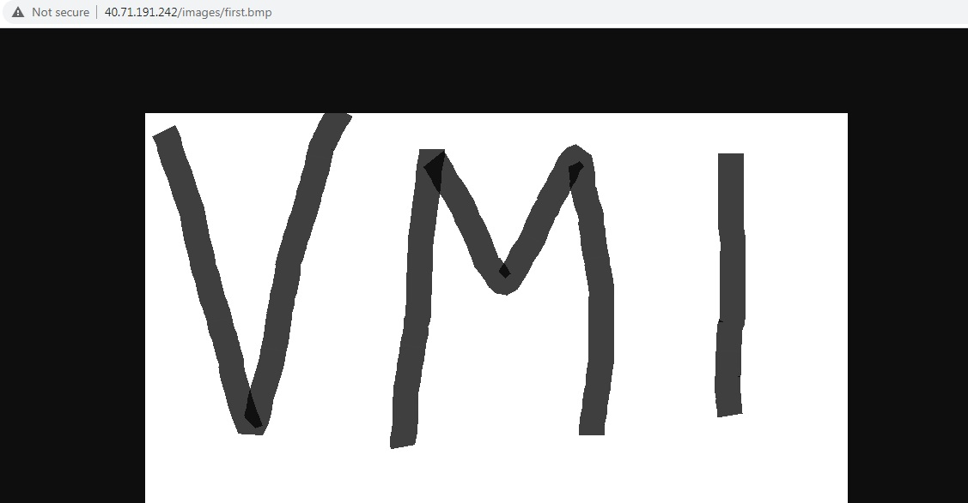

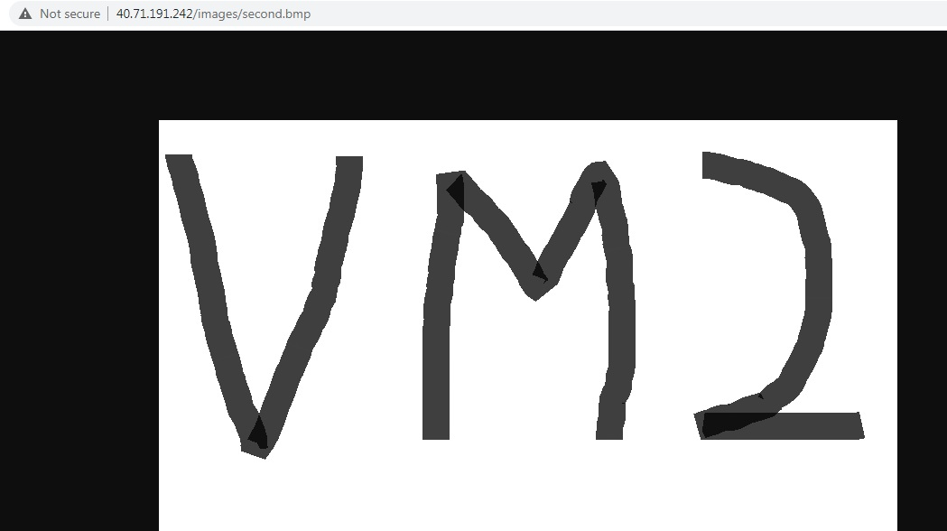

## STEP 7 : Add application gateways to the Traffic Manager endpoints

Create an endpoint by entering the following information-

* Type: Azure endpoint
* Name: trafend
* Target resource type: Public IP address
* Public Ip address : npb1 (40.71.191.242)

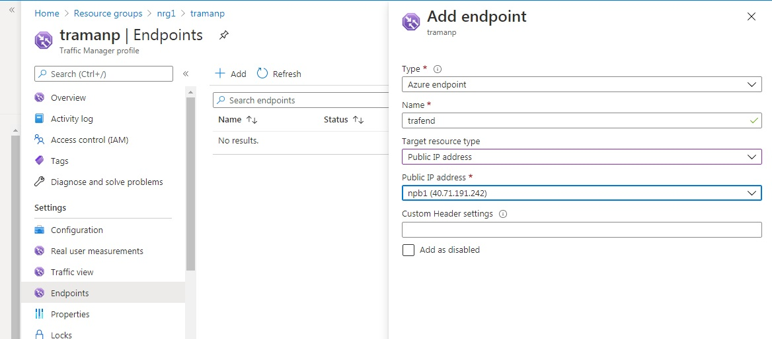

**Test by traffic Manager Profiles**

